**Week 1**

Design UI App

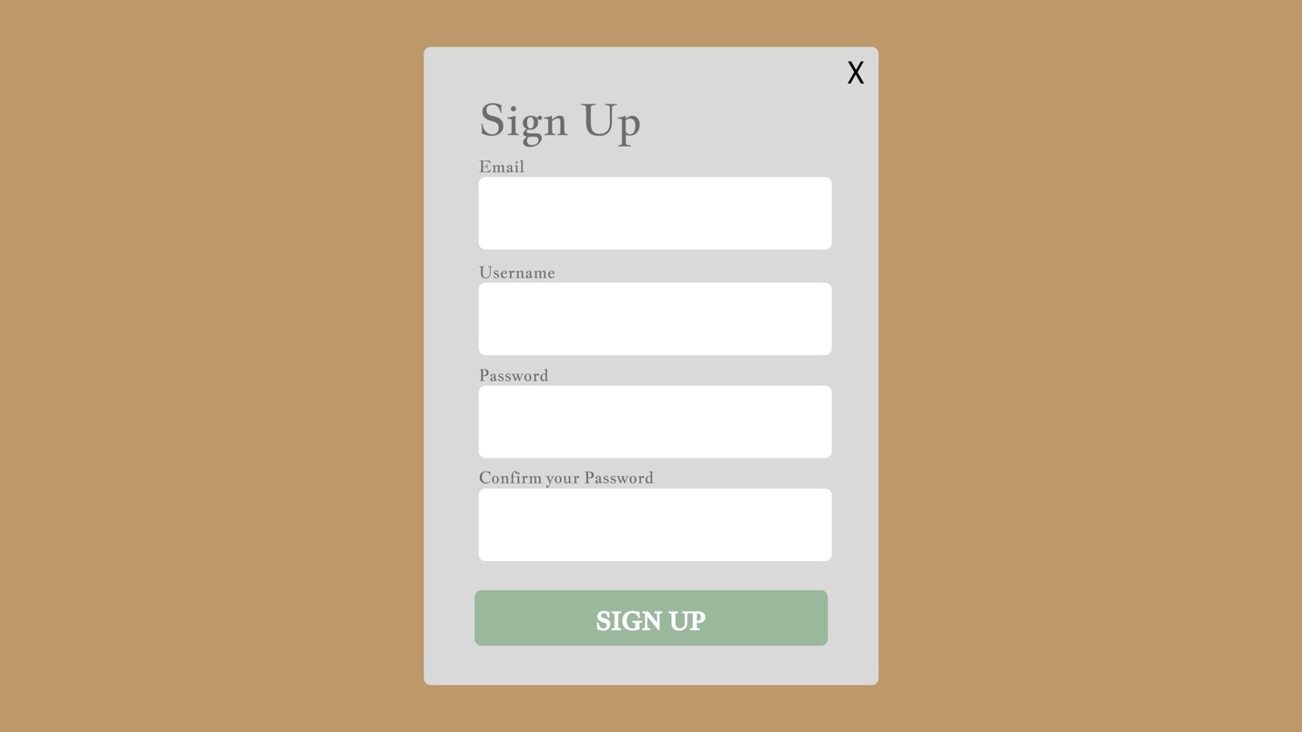

**Week 2**

Create Navbar Component include route home page



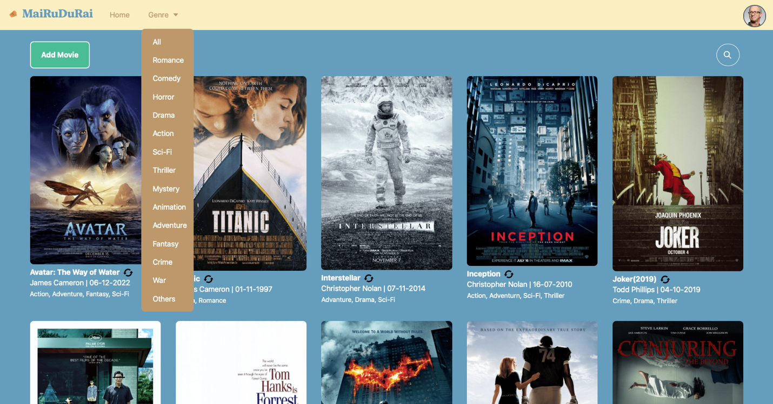

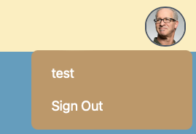

**Week 3**

create Search Toggle, write filteredMovies to filter movies name use to search movies, show all movies and fetch movies from backend

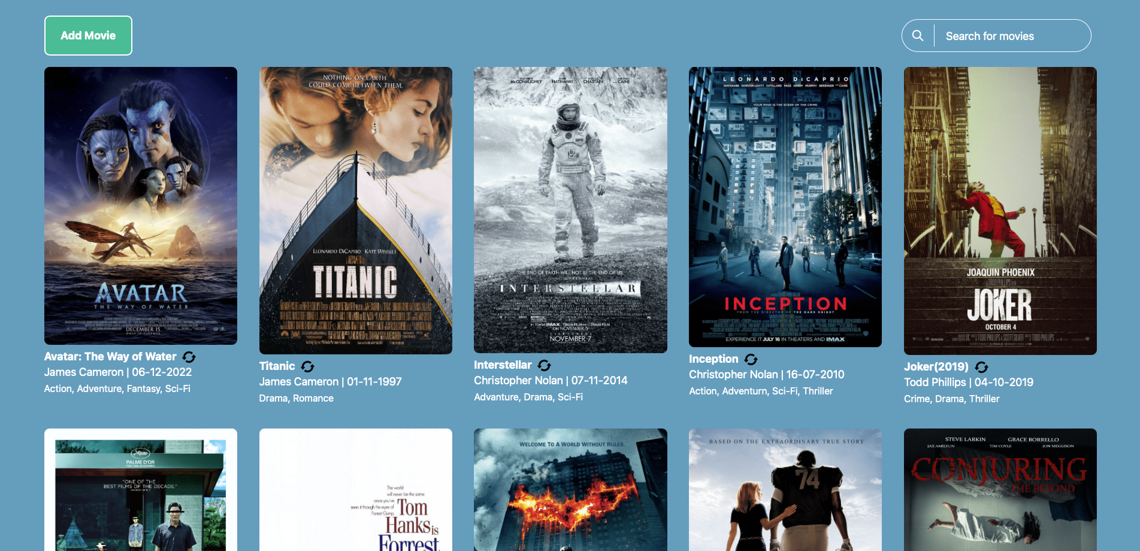

**Week 4**

Create each movie details page, fetch movies from backend and route

